|  |
| --- |
| **SOLUTION DESIGN** |

|  |  |
| --- | --- |
| **Document Information** | |
| **Project** | GreenVet |
| **Document name** | GV_Solution Design for GAP |
| **Creator** |  |
| **Version** |  |
| **Last update** |  |

| **RECORD OF CHANGES** | | | |
| --- | --- | --- | --- |
| **Version** | **Change Description** | **Author** | **Effective Date** |
| 0.1 | Create document |  | 06/06/2017 |
|  | Update document |  | 07/06/2017 |
|  | Update document |  | 08/06/2017 |

CONTENTS

1. CUSTOMER MANAGEMENT 4

1.1. UC01: Create customer in SFA 6

1.2. UC02: Approve customer in eTool 33

1.3. UC03: Update Rejected Customer In SFA 36

1.4. UC04: View alert about creating customer 40

1.5. UC05: Create customer in Core DMS 41

### CUSTOMER MANAGEMENT

1. **Overview:**

* Vendor wants to manage customer information in system based on customer’s type

1. **User Requirement:**

* Customer in DMS is customer who is served by sales team (SR, TR, TSR, VC) and potential customer in country
* One customer may have many difference locations. Sales team (SR, TR, TSR, VC) visits each location of customer
* Customer has 2 main parts:
  + Customer information
  + Delivery information (Ship-to)
* First, user import all customers in DMS by excel file. After that, there are 2 ways to create new customer: create by salesman (need approved by sales manager) or create by Sales Admin from each company.
* Customer code rules: system auto generates customer code begin with prefix 8 and contain 10 character (ex: 8000000601)
* Parent code:
  + Agency level 2 is belonged to agency level 1
  + Farm is belonged to agency level 1 or level 2
* When creating new customer at company system check information: tax code or phone or business license to alert customer has existed in system.
* Customer will create from each company then sync to HO company, when sync customer to HO system will check tax code or phone or business license to create new HO code in case not exist, in case exist system will get HO code to update for this customer.
* Customer have multiple ship-to, System able to define main ship-to allow SR get sales order at main ship-to and assign ship-to for delivery order
* Assumption: DMS and EPICOR is real-time integrated with each other.

1. **Process:**



1. **List of use case:**

* **Use case 01:** create customer in SFA
* **Use case 02:** approve customer in eTool
* **Use case 03:** update rejected customer by eTool user
* **Use case 04:** view alert about new created customer
* **Use case 05:** create customer in Core DMS

1. **Assumption**
2. **Impact**

* SAP: alert about new created customer. System auto generates customer code based on the customer’s type
* SFA: create new customer with specific customer’s type, update customer information
* eTool: approve customer or not. If not, input the reason of reject

#### UC01: Create customer in SFA

|  |  |
| --- | --- |
| **Brief description** | This use case is run when salesman creates customer information in SFA |
| **Actor** | Salesman |
| **User Goal** | Customer information is created and sent to server |
| **Preconditions** | * User logged in successfully |
| **Post-conditions** | Customer information is created and sent to server successfully |
| **Trigger** | User wants to create new customer |

* **Main Success Scenario:**

1. Salesman select which type of customer that he wants to create
2. Salesman creates new customer information
3. Salesman saves information
4. System saves information and sends to server
5. Salesman takes order to new customer
6. System saves information and sends to server

* **Alternative:**

2a. Salesman cancels inputted information

2a.1. Use case ends

* **Business Rules:**
* Salesman find customer in customer list by Customer Name, Address, Phone, Tax code, Business license… In case customer not exist sales will create new customer
* Salesman has to select which type of customer that he wants to create

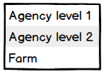

* Salesman has to input mandatory information to save
* When creating new customer, system checks tax code, business license or phone to alert customer has existed in system (system check tax code or business license or phone.

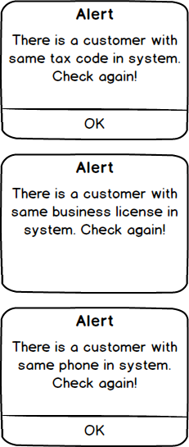

##### Screen 01 (SFA): Create customer information (Agency)

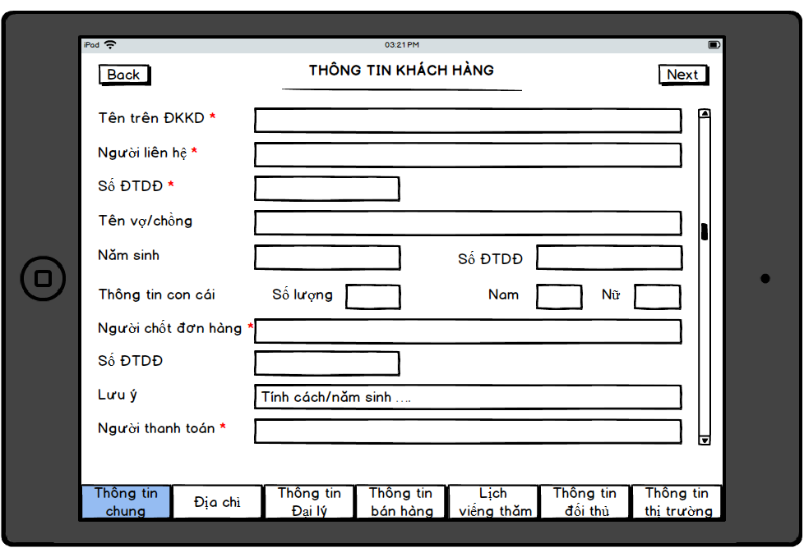

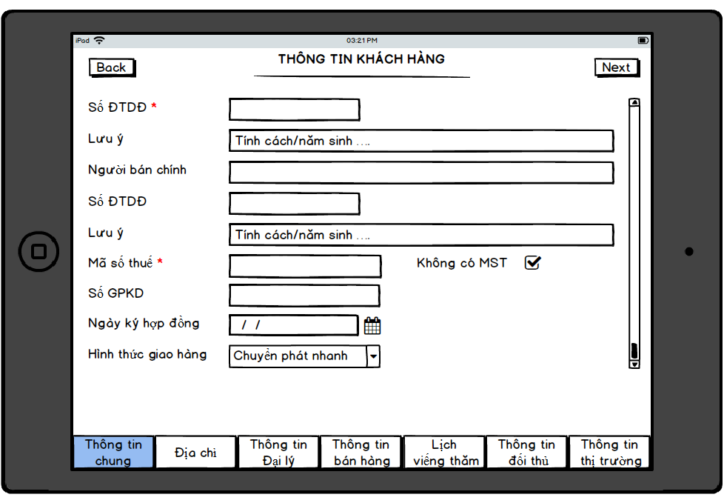

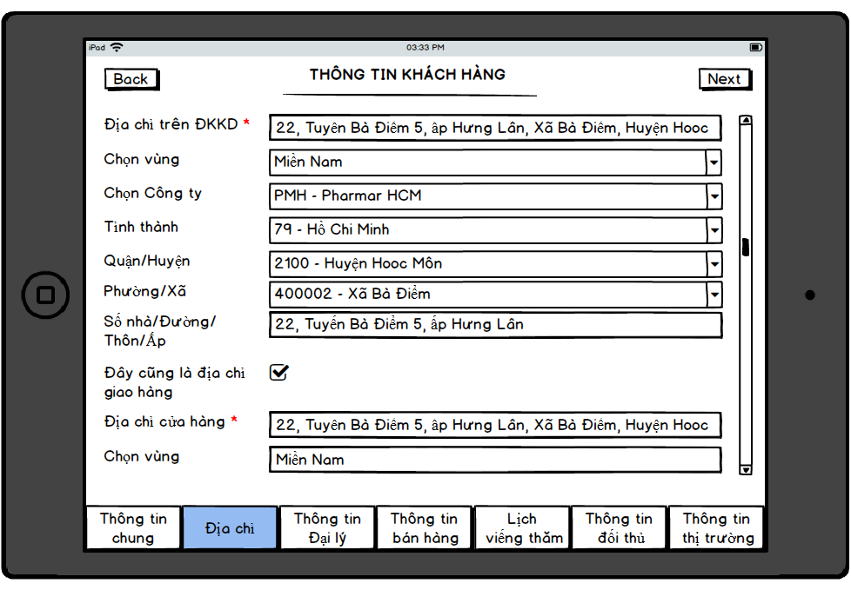

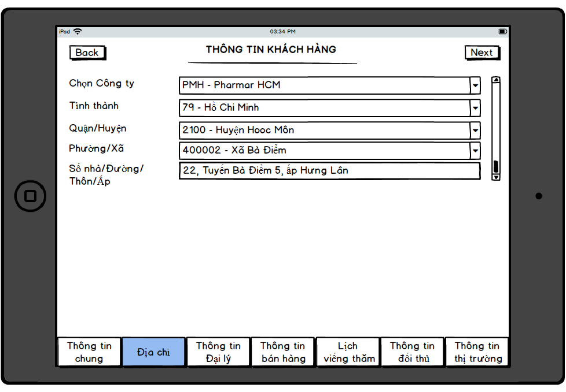

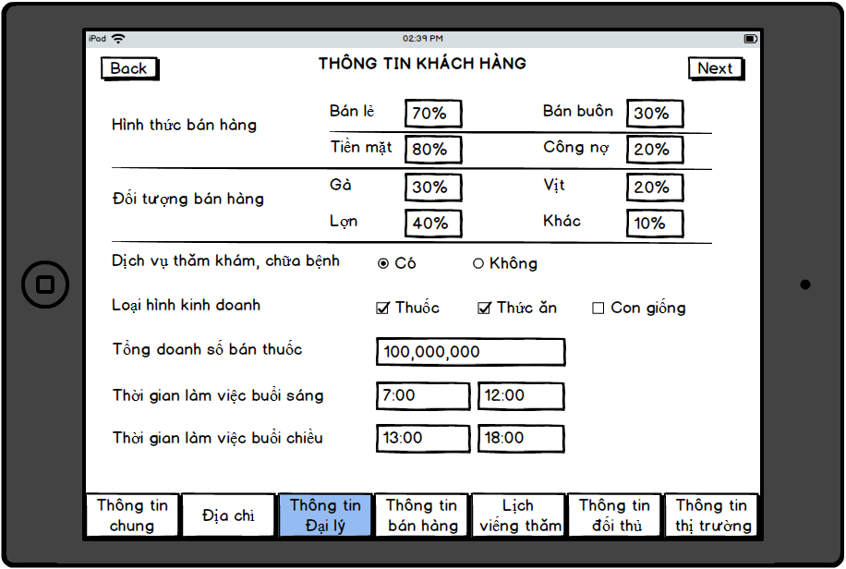

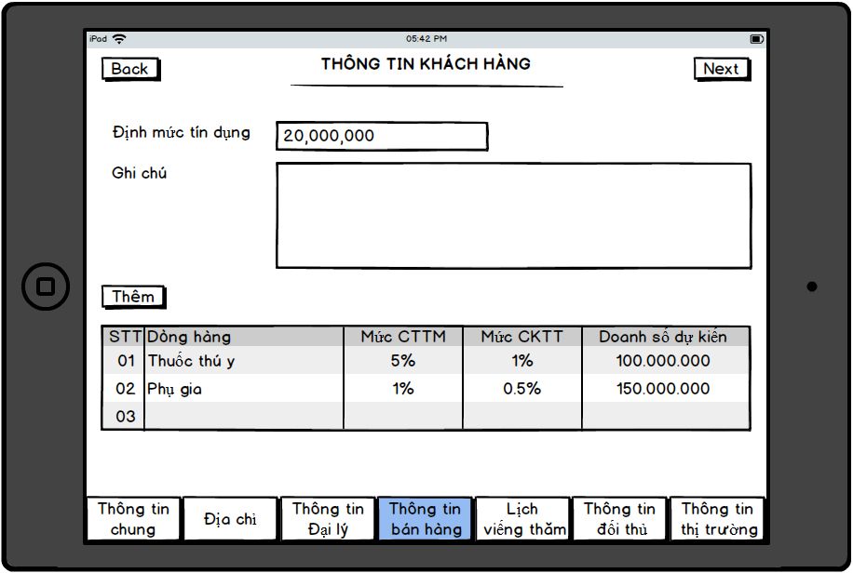

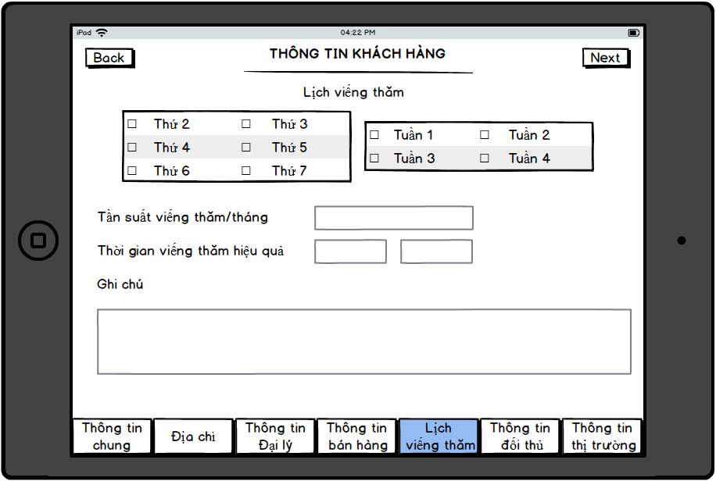

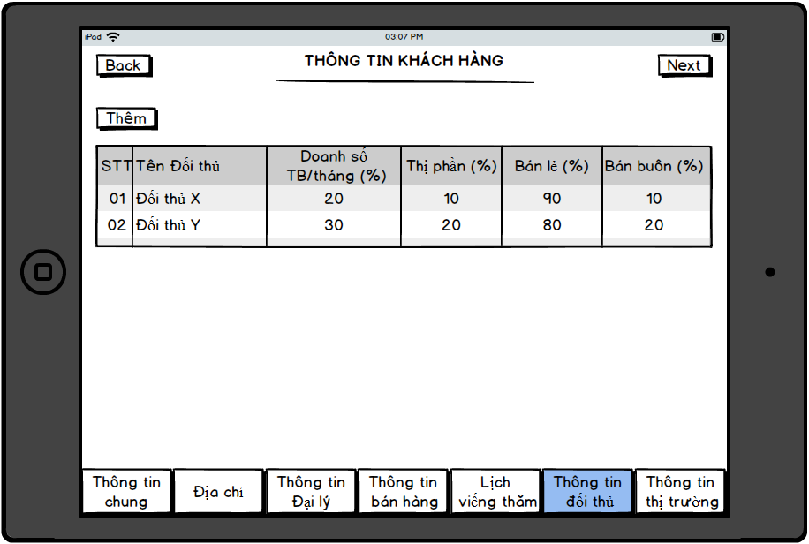

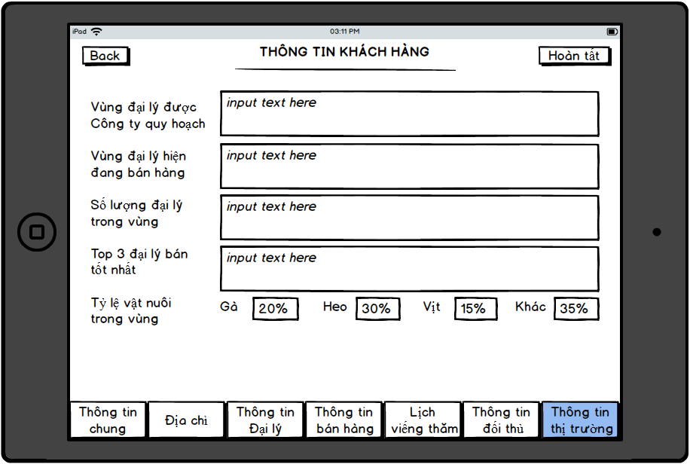

* **Screen Description**

|  |  |  |  |  |
| --- | --- | --- | --- | --- |
| **Element** | **Type** | **Length** | **Default Value** | **Description and Rules** |
| **Thông tin chung** | | | | |
| Tên trên ĐKKD |  |  |  |  |
| Người liên hệ |  |  |  |  |
| Số ĐTDĐ |  |  |  |  |
| Tên vợ/chồng |  |  |  |  |
| Năm sinh |  |  |  |  |
| Số ĐTDĐ |  |  |  |  |
| Thông tin con cái: Số lượng |  |  |  |  |
| Thông tin con cái : Nam |  |  |  |  |
| Thông tin con cái : Nữ |  |  |  |  |
| Người chốt đơn hàng |  |  |  |  |
| Số ĐTDĐ |  |  |  |  |
| Lưu ý |  |  |  |  |
| Người thanh toán |  |  |  |  |
| Số ĐTDĐ |  |  |  |  |
| Lưu ý |  |  |  |  |
| Người bán chính |  |  |  |  |
| Số ĐTDĐ |  |  |  |  |
| Lưu ý |  |  |  |  |
| Mã số thuế |  |  |  |  |
| Không có MST | Check box |  |  |  |
| Số GPKD |  |  |  |  |
| Ngày ký hợp đồng |  |  |  |  |
| Hình thức giao hàng |  |  |  |  |
| **Địa chỉ** | | | | |
| Địa chỉ trên ĐKKD |  |  |  |  |
| Chọn vùng |  |  |  |  |
| Chọn công ty |  |  |  |  |
| Tỉnh thành |  |  |  |  |
| Quận/huyện |  |  |  |  |
| Phường/xã |  |  |  |  |
| Số nhà/đường/thôn/ấp |  |  |  |  |
| Đây cũng là địa chỉ giao hàng | Check box |  |  |  |
| Địa chỉ cửa hàng |  |  |  |  |
| Chọn vùng |  |  |  |  |
| Chọn công ty |  |  |  |  |
| Tỉnh thành |  |  |  |  |
| Quận/huyện |  |  |  |  |
| Phường/xã |  |  |  |  |
| Số nhà/đường/thôn/ấp |  |  |  |  |
| **Thông tin khách hàng** | | | | |
| Hình thức bán hàng: Bán lẻ |  |  |  |  |
| Hình thức bán hàng: Bán buôn |  |  |  |  |
| Hình thức bán hàng: Tiền mặt |  |  |  |  |
| Hình thức bán hàng: Công nợ |  |  |  |  |
| Đối tượng bán hàng: Gà |  |  |  |  |
| Đối tượng bán hàng: Vịt |  |  |  |  |
| Đối tượng bán hàng: Lợn |  |  |  |  |
| Đối tượng bán hàng: Khác |  |  |  |  |
| Dịch vụ thăm khám chữa bệnh |  |  |  |  |
| Loại hình kinh doanh |  |  |  |  |
| Tổng doanh số bán thuốc |  |  |  |  |
| Thời gian làm việc buổi sáng |  |  |  |  |
| Thời gian làm việc buổi chiều |  |  |  |  |
| **Thông tin bán hàng** | | | | |
| Định mức tín dụng |  |  |  |  |
| Ghi chú |  |  |  |  |
| Thêm |  |  |  |  |
| STT |  |  |  |  |
| Dòng hàng |  |  |  |  |
| Mức CTTM |  |  |  |  |
| Mức CKTT |  |  |  |  |
| Doanh số dự kiến |  |  |  |  |
| **Lich viếng thăm** | | | | |
| Thứ (2,3,4,5,6,7,CN) |  |  |  |  |
| Tuần (1,2,3,4) |  |  |  |  |
| Tần suất viếng thăm/tháng |  |  |  |  |
| Thời gian viếng thăm hiệu quả |  |  |  |  |
| Ghi chú |  |  |  |  |
| **Thông tin đối thủ** | | | | |
| Thêm |  |  |  |  |
| STT |  |  |  |  |
| Tên đối thủ |  |  |  |  |
| Doanh số TB/tháng |  |  |  |  |
| Thị phần |  |  |  |  |
| Bán lẻ |  |  |  |  |
| Bán buôn |  |  |  |  |
| **Thông tin thị trường** | | | | |
| Vùng đại lý được Công ty quy hoạch |  |  |  |  |
| Vùng đại lý hiện đang bán hàng |  |  |  |  |
| Số lượng đại lý trong vùng |  |  |  |  |
| Top 3 đại lý bán tốt nhất |  |  |  |  |
| Tỷ lệ vật nuôi trong vùng: Gà |  |  |  |  |
| Tỷ lệ vật nuôi trong vùng: Heo |  |  |  |  |
| Tỷ lệ vật nuôi trong vùng: Vịt |  |  |  |  |
| Tỷ lệ vật nuôi trong vùng: Khác |  |  |  |  |
| Hoàn tất | Button |  |  |  |

##### Screen 02 (SFA): Create customer information (Farm)

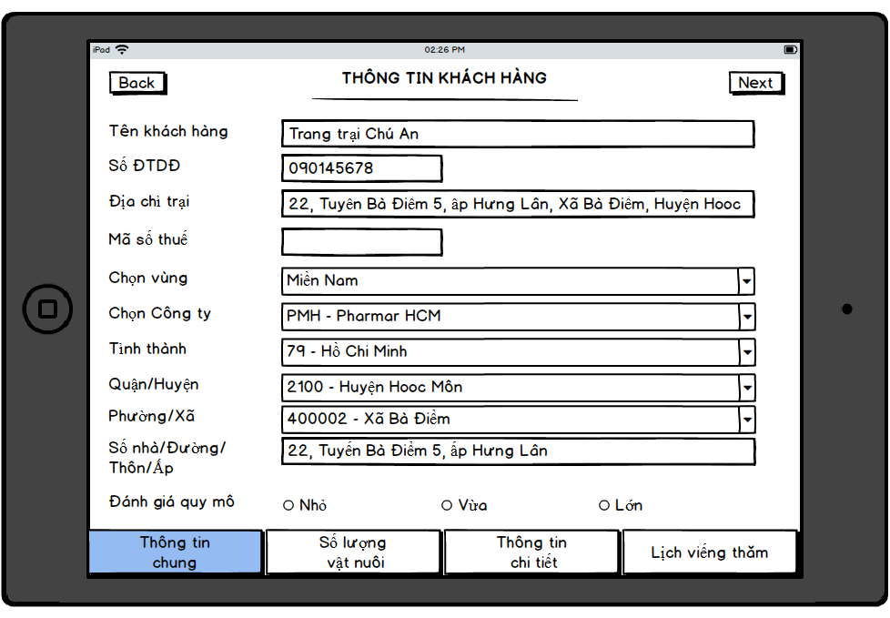

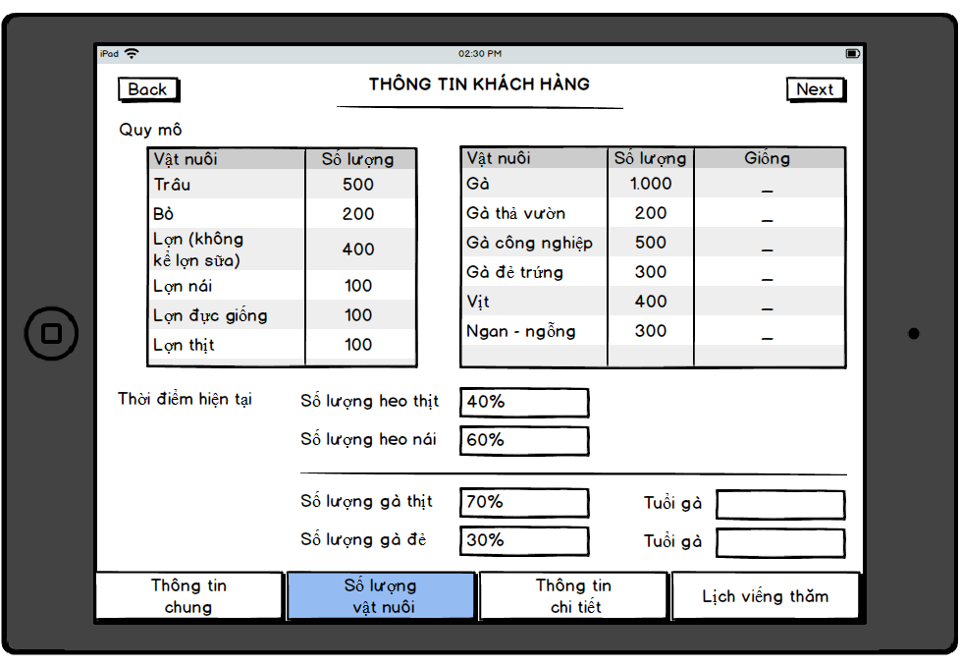

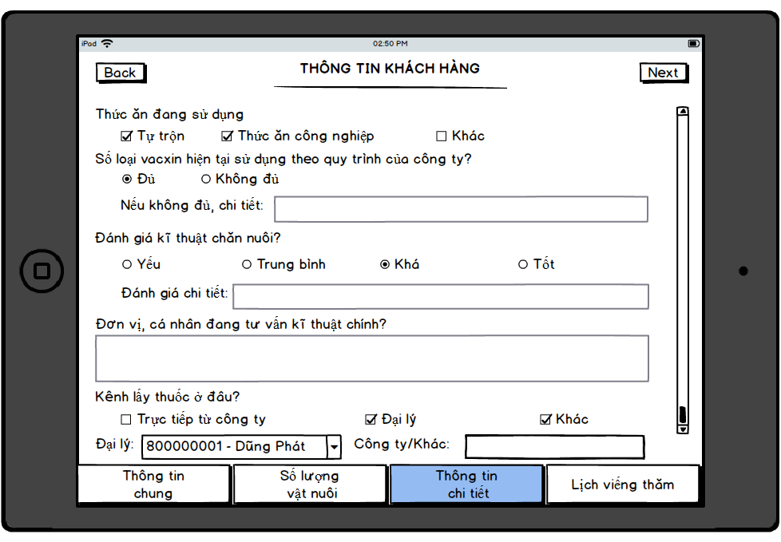

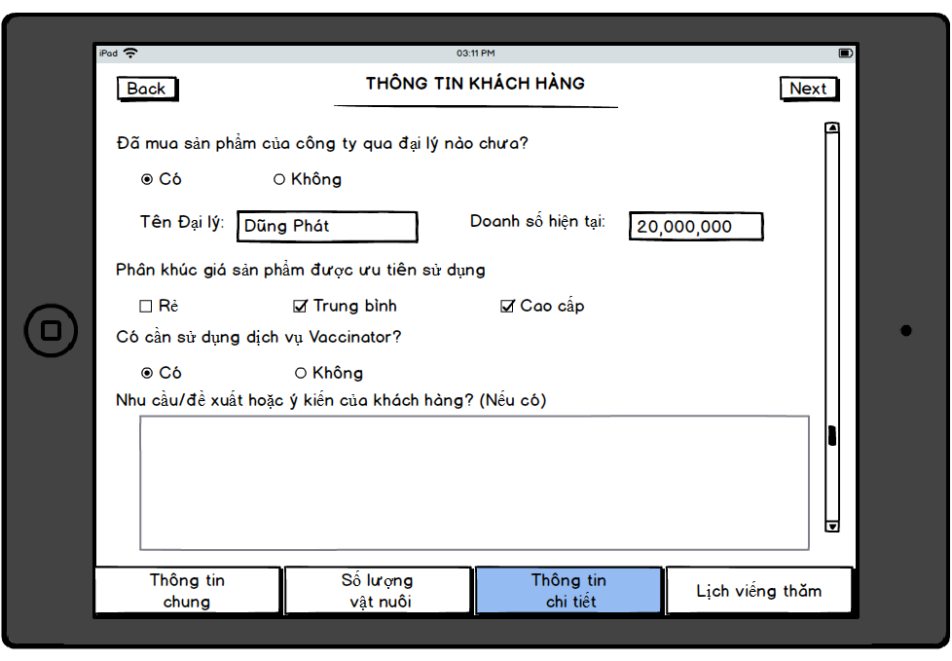

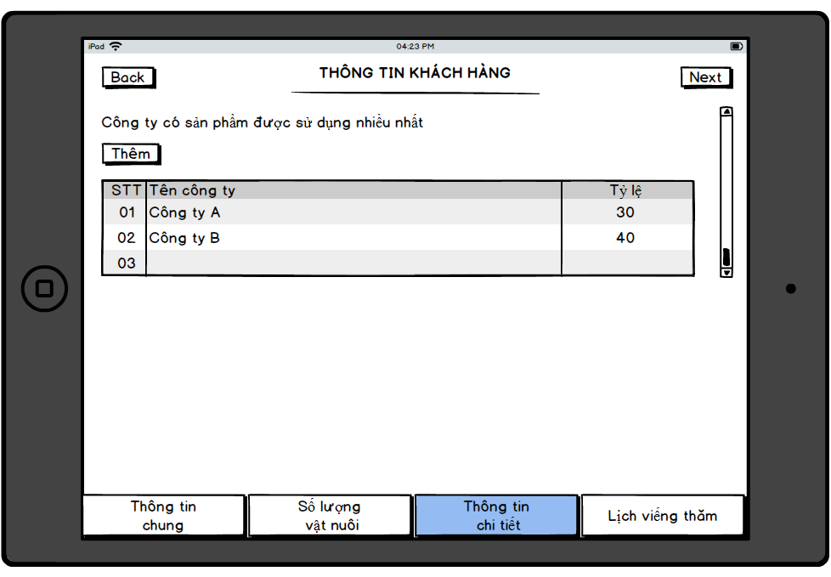

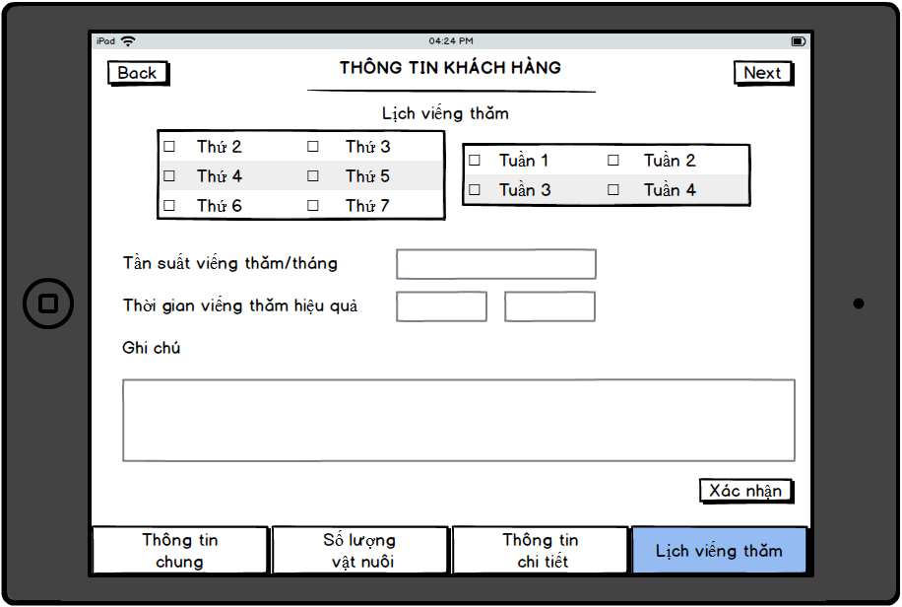

* **Screen Description**

|  |  |  |  |  |
| --- | --- | --- | --- | --- |
| **Element** | **Type** | **Length** | **Default Value** | **Description and Rules** |
| **Thông tin chung** | | | | |
| Tên khách hàng |  |  |  |  |
| Số ĐTDĐ |  |  |  |  |
| Địa chỉ trại (1) |  |  |  |  |
| Địa chỉ trại (2) |  |  |  |  |
| Mã số thuế |  |  |  |  |
| Đánh giá quy mô |  |  |  |  |
| **Số lượng vật nuôi** | | | | |
| Trâu |  |  |  |  |
| Bò |  |  |  |  |
| Lợn (không kể lợn sữa) |  |  |  |  |
| Lợn nái |  |  |  |  |
| Lợn đực giống |  |  |  |  |
| Lợn thịt |  |  |  |  |
| Gà |  |  |  |  |
| Gà thả vườn |  |  |  |  |
| Gà công nghiệp |  |  |  |  |
| Gà đẻ trứng |  |  |  |  |
| Vịt |  |  |  |  |
| Ngan-ngỗng |  |  |  |  |
| Số lượng heo thịt |  |  |  |  |
| Số lượng heo nái |  |  |  |  |
| Số lượng gà thịt |  |  |  |  |
| Tuổi gà |  |  |  |  |
| Số lượng gà đẻ |  |  |  |  |
| Tuổi gà |  |  |  |  |
| **Thông tin chi tiết** | | | | |
| Thức ăn đang sử dụng |  |  |  |  |
| Số loại vacxin hiện tại sử dụng theo quy trình của Công ty? |  |  |  |  |
| Chi tiết |  |  |  |  |
| Đánh giá kĩ thuật chăn nuôi |  |  |  |  |
| Chi tiết |  |  |  |  |
| Đơn vị, cá nhân đang tư vấn kĩ thuật chính |  |  |  |  |
| Kênh lấy thuốc ở đâu |  |  |  |  |
| Chi tiết |  |  |  |  |
| Đã mua sản phẩm của công ty qua đại lý nào chưa |  |  |  |  |
| Chi tiết |  |  |  |  |
| Doanh số hiện tại |  |  |  |  |
| Phân khúc giá sản phẩm được ưu tiên sử dụng |  |  |  |  |
| Có cần sử dụng dịch vụ vaccinator |  |  |  |  |
| Ghi chú |  |  |  |  |
| Thêm | Button |  |  |  |
| STT |  |  |  |  |
| Tên công ty |  |  |  |  |
| Tỷ lệ |  |  |  |  |
| **Lịch viếng thăm** | | | | |
| Thứ (2,3,4,5,6,7,CN) |  |  |  |  |
| Tuần (1,2,3,4) |  |  |  |  |
| Tần suất viếng thăm/tháng |  |  |  |  |
| Thời gian viếng thăm hiệu quả |  |  |  |  |
| Ghi chú |  |  |  |  |
| Xác nhận | Button |  |  |  |

#### UC02: Approve customer in eTool

|  |  |
| --- | --- |
| **Brief description** | This use case is run when user reviews and approves customer created by salesman |
| **Actor** | User who has the following permission:   * Approve customer created by salesman |
| **User Goal** | Customer is approved in eTool |
| **Preconditions** | * User logged in successfully * Customer is created by salesman |
| **Post-conditions** | Customer is approved in eTool |
| **Trigger** | User wants to approve customer in eTool |

* **Main Success Scenario:**

1. User reviews and approves customer information created by salesman
2. System saves information and sends to server
3. Core DMS auto creates customer’s code based on the customer’s type
4. System integrates customer to EPICOR

* **Alternative:**

1a. User denies customer information

1a.1. System saves information and sends “denied” status to SFA

1a.2. Salesman updates information and re-sends to server *🡪 back to UC01*

* **Business Rules:**

1.

* User has 2 options: approve or deny
  + Approve: customer is approved and sent to server 🡪 waiting HO to approve
  + Deny: user has to selects reason of reject to to confirm about the reject 🡪 customer is denied and sent to server 🡪 salesman can view and update customer or not

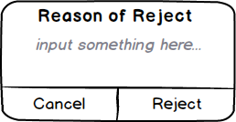

**Note:** First, cancel button is able and reject button is disable. When user input something about reason of reject, the reject button is enable and user can reject customer 🡪 system saves information and sends to SFA

3. Customer code rules: system auto generates customer code begin with prefix 8 and contain 10 character (ex: 8000000601)

##### Screen 01 (SFA): Approve customer in eTool

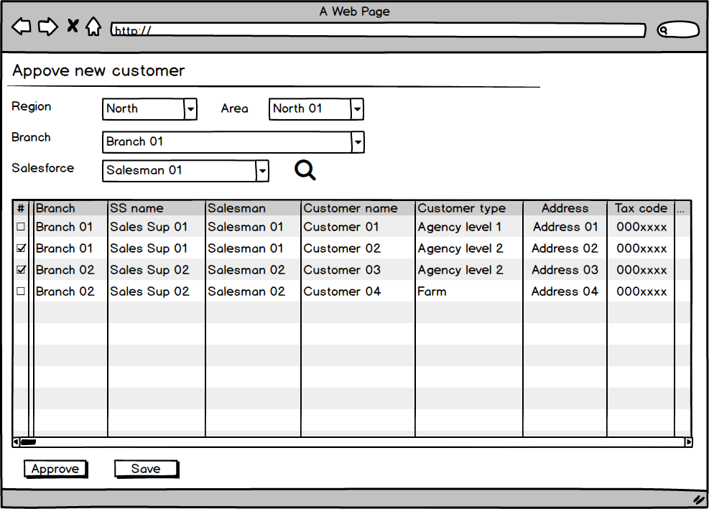

* **Screen Description**

|  |  |  |  |  |
| --- | --- | --- | --- | --- |
| **Element** | **Type** | **Length** | **Default Value** | **Description and Rules** |
|  |  |  |  |  |
|  |  |  |  |  |

#### UC03: Update Rejected Customer In SFA

|  |  |
| --- | --- |
| **Brief description** | This use case is run when salesman updates rejected customer by eTool user |
| **Actor** | Salesman |
| **User Goal** | Customer information is updated and sent to server |
| **Preconditions** | * User logged in successfully |
| **Post-conditions** | Customer information is updated and sent to server successfully |
| **Trigger** | Salesman wants to updates rejected customer |

* **Main Success Scenario:**

1. Salesman updates rejected customer information
2. Salesman saves information
3. System saves information and sends to server (waiting for sales manager approved again)

* **Alternative:**

1a. Salesman cancels inputted information

1a.1. Use case ends

* **Business Rules:**

1.

* Salesman only can update rejected customer (with “SM từ chối” status)

##### Screen 01 (SFA): List of created customer in SFA

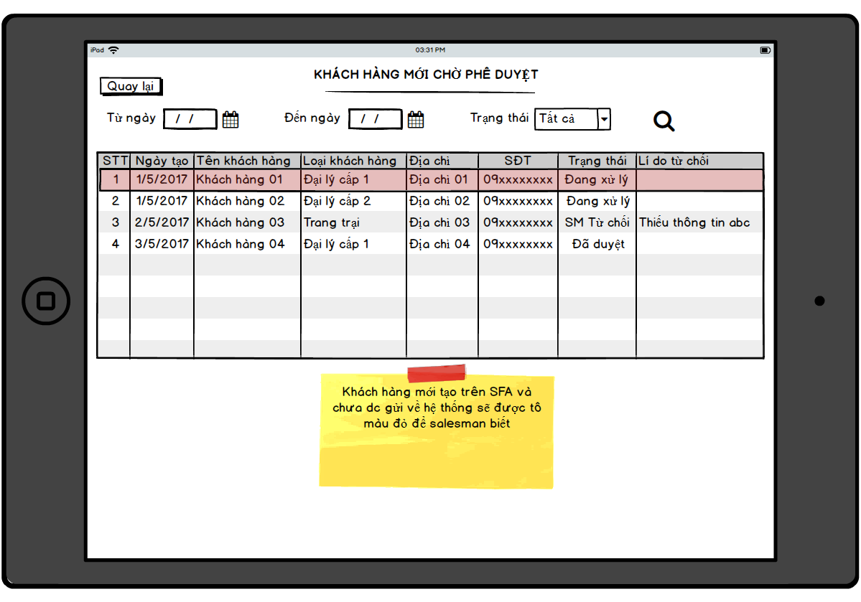

* **Screen Description**

|  |  |  |  |  |
| --- | --- | --- | --- | --- |
| **Element** | **Type** | **Length** | **Default Value** | **Description and Rules** |
| From date | Date time |  | Blank |  |
| To date | Date time |  | Blank |  |
| Status | Combo box |  | Blank |  |
| No. | Number |  | Blank |  |
| Created Date | Date time |  | Blank |  |
| Customer name | Text |  | Blank |  |
| Customer type | Text |  | Blank |  |
| Address | Text |  | Blank |  |
| Phone | Number |  | Blank |  |
| Status | Text |  | Blank | There are 4 status of new customer:   * Not sent yet: new customer ‘ve just created and data is saved in SFA and ‘ve not set to server yet * After SFA syncs to server, the status is changed to Processing * Processing: waiting for SM to approve * Denied: SM denied new customer * Salesman can tap on customer and update information and re-send to server * Approved: Approved by sales manager (just show approved customer in the last 7 days in PDA) |
| Reason of reject | Text |  | Blank | Reason of reject by SM |

#### UC04: View alert about creating customer

|  |  |
| --- | --- |
| **Brief description** | This use case is run when user approves customer after approving in Core DMS |
| **Actor** | User who has the following permission:   * View alert about creating customer |
| **User Goal** | View alert about new created customer |
| **Preconditions** | * User logged in successfully * New customer is approved in eTool |
| **Post-conditions** | Alert is showed for user to view successfully  If customer type is agency level 1, customer information is integrated to EPICOR |
| **Trigger** | User logs in and views alert about all new created customer |

* **Main Success Scenario:**

1. System shows alert about new created customer when user logs in
2. User clicks on each alert to view new customer information

* **Alternative:**
* **Business Rules:**

1. Each new created customer is one alert. When user clicks on the alert, system opens the BP screen

##### Screen 01 (SFA): Approve customer in Core DMS

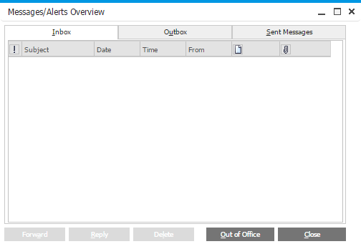

* **Screen Description**

|  |  |  |  |  |
| --- | --- | --- | --- | --- |
| **Element** | **Type** | **Length** | **Default Value** | **Description and Rules** |
|  |  |  |  |  |
|  |  |  |  |  |

#### UC05: Create customer in Core DMS

|  |  |
| --- | --- |
| **Brief description** | This use case is run when user wants to create new customer in Core DMS |
| **Actor** | User who has the following permission(s):   * Create new customer in Core DMS |
| **User Goal** | Customer is created in Core DMS |
| **Preconditions** | * Information of customer * User logged in successfully |
| **Post-conditions** | Customer is created in Core DMS  If customer’s type is agency level 1, customer’s information is integrated to EPICOR |
| **Trigger** | User wants to create new customer in Core DMS |

* **Main Success Scenario:**

1. User creates customer in Core DMS
2. System saves information
3. System integrates customer to EPICOR

* **Alternative:**

1a. User updates customer in Core DMS

1a.1. System saves information

1a.2. System integrates customer to EPICOR

* **Business Rules:**

1.

- User can creates customer manually or upload by excel file

* When creating new customer, user selects customer’s type and system will auto create a customer’s code. Customer code rules:
  + Agency level 1: start at 8, contain 9 following number (Example: 8000000601)
  + Agency level 2: start at 7, contain 9 following number (Example: 7000000601)
  + Farm: start at 6, contain 9 following number (Example: 6000000601)

3. Only agency level 1 customer is integrated to EPICOR

3a. Only agency level 1 customer is integrated to EPICOR

##### Screen 01 (SAP): Create customer in Core DMS

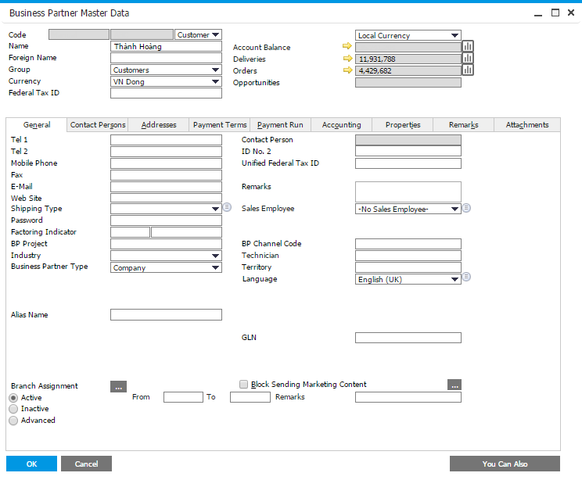

* **Screen Description**

|  |  |  |  |  |
| --- | --- | --- | --- | --- |
| **Element** | **Type** | **Length** | **Default Value** | **Description and Rules** |
|  |  |  |  |  |
|  |  |  |  |  |